**Executive Summary**

Bicycle sharing systems are popular around the world, there are many services running on different countries/cities, people use these services daily because it is a clean way to ride to their destination and return the bicycle in any available station.

While people usually go straightaway to take a bicycle, it is useful to plan your route in advance, therefore these services usually offer APPs or Web Services where it is possible to check the availability of bicycles in every station in real time, but many times, I have faced the scenario where in my way to the station, all the bicycles are taken and I have to go back to the bus stop, losing time and getting a bad user experience.

The aim of this report is to predict the demand of bicycles in Dublin, Ireland specifically on the service Dublin Bike based on the time and some other variables described in the report. This information could be presented into the APPs or Web Services available and therefore people could plan their routes in advance, getting a better user experience on the service.

**Introduction**

According to a study perform by “Hexa Research”, the global bike rental market is expected to reach USD 4.00 billion by 2025. Increasing penetration, easy access, attractive pricing, and support of local authorities are among the key driving factors driving the growth of bike rental services. Leveraging of digital platforms by service providers is also expected to add to the growing adoption of rental services in the coming years.

<https://www.prnewswire.com/news-releases/global-bike-rental-market-to-reach-usd-4-00-billion-by-2025-hexa-research-300816295.html>

Depending on the country/city where the service is provided, there are different business models, but the most popular one is to charge a fixed amount per year for a subscription that gives a certain amount of time to use a bicycle, then if the user exceeds that time, a small extra amount is charged to their accounts.

Included on the subscription, companies usually provide a service to their users that allows them to check the availability of bicycles in each station in real time, such as web sites or mobile apps, but these services do not usually report about the availability of bicycles in the future.

Based on the last premise, this report is focused on find which algorithms of data analysis are capable of predict the availability of bicycles per station in the future and then make possible the idea of adding this as a new feature in the web sites and mobiles apps.

What motivates me to develop this research and conduct this analysis is the fact that this is a problem that I have faced many times in my daily life, the bicycle station is 10 minutes walking from the bus stop, and while it is faster to ride a bicycle to reach my destination every day, in many occasions I had to go back because all the bicycles are taken on my way to the station, therefore it will be amazing to have a system that predicts the bicycles available in the future, so I can go earlier if I want to take one, or I can decide to go straightaway to the bus stop instead of losing time walking towards the bicycle station.

**DATASET**

In this opportunity a dataset from Dublin Bike, a bicycle sharing system present on Dublin, Ireland is going to be used in order to perform the data analysis.

Our dataset was obtained from data.smartdublin.ie an contains information about each station in Dublin during the year 2019.

<https://data.smartdublin.ie/dataset/dublinbikes-api>

The data fields on the dataset are described as:

|  |  |  |
| --- | --- | --- |
| **Label** | **Type** | **Description** |
| STATION ID | numeric | Globally unique identifier of station. |
| TIME | timestamp | Time of fetching the data. |
| LAST UPDATED | timestamp | Time of last updated information. |
| NAME | text | Station name. |
| BIKE STANDS | numeric | Station total number of bike stands. |
| AVAILABLE BIKE STANDS | numeric | Station available bike stands. |
| AVAILABLE BIKES | numeric | Station available bikes |
| STATUS | text | Station status (Open/Close). |
| ADDRESS | text | Station address. |
| LATITUDE | numeric | Station latitude. |
| LONGITUDE | numeric | Station longitude. |

Number of instances: 10.741.878

Number of attributes: 11

Since this dataset just provides information about the bicycles, which is not enough for our prediction, a dataset with the weather information per hour during 2019 was obtained from openweathermap.org

<https://openweathermap.org/history-bulk>

The data fields on the dataset are described as:

|  |  |  |
| --- | --- | --- |
| **Label** | **Type** | **Description** |
| dt | numeric | Time of data calculation, unix, UTC |
| dt_iso | datetime | Date and time in UTC format |
| timezone | numeric | Shift in seconds from UTC |
| city_name | text | City name |
| lat | numeric | Geographical coordinates of the location (latitude) |
| lon | numeric | Geographical coordinates of the location (longitude) |
| temp | numeric | Temperature |
| feels_like | numeric | This temperature parameter accounts for the human perception of weather |
| temp_min | numeric | Minimum temperature at the moment. |
| temp_max | numeric | Minimum temperature at the moment. |
| pressure | numeric | Atmospheric pressure (on the sea level), hPa |
| sea_level | text | Deprecated |
| grnd_level | text | Deprecated |
| humidity | numeric | Humidity, % |
| wind_speed | numeric | Wind speed. Unit Default: meter/sec |
| wind_deg | numeric | Wind direction, degrees (meteorological) |
| rain_1h | numeric | Rain volume for the last hour, mm |
| rain_3h | numeric | Rain volume for the last 3 hours, mm |
| snow_1h | numeric | Snow volume for the last hour, mm (in liquid state) |
| snow_3h | numeric | Snow volume for the last 3 hours, mm (in liquid state) |
| clouds_all | numeric | Cloudiness, % |
| weather_id | numeric | Weather condition id |
| weather_main | text | Group of weather parameters (Rain, Snow, Extreme etc.) |
| weather_description | text | Weather condition within the group |
| weather_icon | text | Weather icon id |

Number of instances: 8.955

Number of attributes: 25

**Methodology**

Top of Form

data preparation and cleaning

Bottom of Form

**Data preparation and cleaning**

The first step will be the preparation of the data obtained from the datasets, the first dataset obtained from “smartdublin” is separated in four files dividing the year in quarters, also contains information of every station in Dublin, but this project will be focused on the specific station St James Hospital (Luas), that is the one near to my place. Then, a new dataset file was generated using a script in python (preparation_dublin_bike.py) that is shared into the script folder of the annex, this new dataset file (filtered_dublinbikes_2019.csv) contains the information of the specific station St James Hospital for the whole year of 2019.

The next step would be to put together both datasets into one file.

In order to do that the column date was splitted into five different columns (“year”. “month”, “day”, “hour”, “minute”) for both datasets, then a new dataset file was created by matching those columns between datasets. The script used for this task is in the folder scripts of the annex (“join_datasets.py”) and the new dataset file was generated in the folder datasets (“joined_dataset.csv”).

The script performed the extraction of the day of the week from the datetime and created a new column “DATE OF THE WEEK” with this data in integer format (#0: Monday ,6: Sunday).

The following step would be to clean the dataset from duplicated, useless or deprecated information, therefore columns "BIKE STANDS", "AVAILABLE BIKE STANDS", “STATION ID”, “TIME”, “LAST UPDATED”, “NAME”, “STATUS”, “ADDRESS”, “LATITUDE”, “LONGITUDE”, “YEAR”, “MINUTES”, “dt”, “dt_iso”, “timezone”, “temp_min”, “temp_max”, “city_name”, “sea_level”, “grnd_level”, “rain_3h”, “snow_1h”, “snow_3h”, “weather_id”, “weather_description”, “weather_icon” were removed from the dataset using the script (“cleaning_dataset.py”).

In the last part of the data preparation a new attribute is going to be added, that is how many bikes available will be there in the station in the next hour, in order to fill this attribute we will use the information available in the table for the next hour and delete the last register of the dataset which does not have any following data to get information from. This task is going to be completed in the script (“cleaning_dataset.py”) and it is going to genera the file “raw_final_dataset.py”.

**Model planning**

Based on the dataset and the type of problem we are facing we will use two different models, the first one would be multiple linear regression, because it is an algorithm that is usually used to predict a variable Y from a set of variables X that are capable of explaining the value of Y. This algorithm assigns a weight to each of the variables X that is used to calculate the value to predict Y.

In this stage a study is going to be performed, comparing the relationship between the attributes of our dataset and the bikes available, all the plots were generated by the script “model_planning_plots.py”.

The comparisons were done in python, and all the plots generated are available in the folder (/plots).

Here we can see tables with the results of the Pearson’s correlation.

(Values equal to 1 or -1 indicate a perfect positive or negative correlation, and values near to 0 indicate a very week or non-existent correlation)

|  |  |
| --- | --- |
| **Pearson’s correlation** |  |
|  | available_bikes_1h |
| available_bikes | 0.865 |
| month | -0.135 |
| day | -0.037 |
| hour | -0.049 |
| day_of_the_week | -0.029 |
| temp | -0.128 |
| feels_like | -0.103 |
| pressure | -0.046 |
| humidity | 0.166 |
| wind_speed | -0.027 |
| wind_deg | -0.009 |
| rain_last_hour | 0.003 |
| clouds_all | 0.006 |
| weather_main | -0.024 |

Based on that table it is clear that the there is a strong correlation between available bikes at the moment and available bikes in one hour, we can also see a weak correlation between bikes available in one hour compared to month, temperature, temperature feels like and humidity in the air, therefore before a data prediction is made, all the other columns with very weak or non-existent correlation are going to be removed in order to improve our prediction.

Our second model for prediction would be, the K-nearest neighbors learning algorithm, that like the multiple linear regression algorithm, is based on assigning weights to certain variables so that the value of the variable to be predicted can then be calculated.

In this case, weights are assigned to the closest K neighbors depending on their distance from the sample. The smaller the distance between the sample to be calculated and any of the neighbors already calculated previously, the greater the weight of that neighbor.

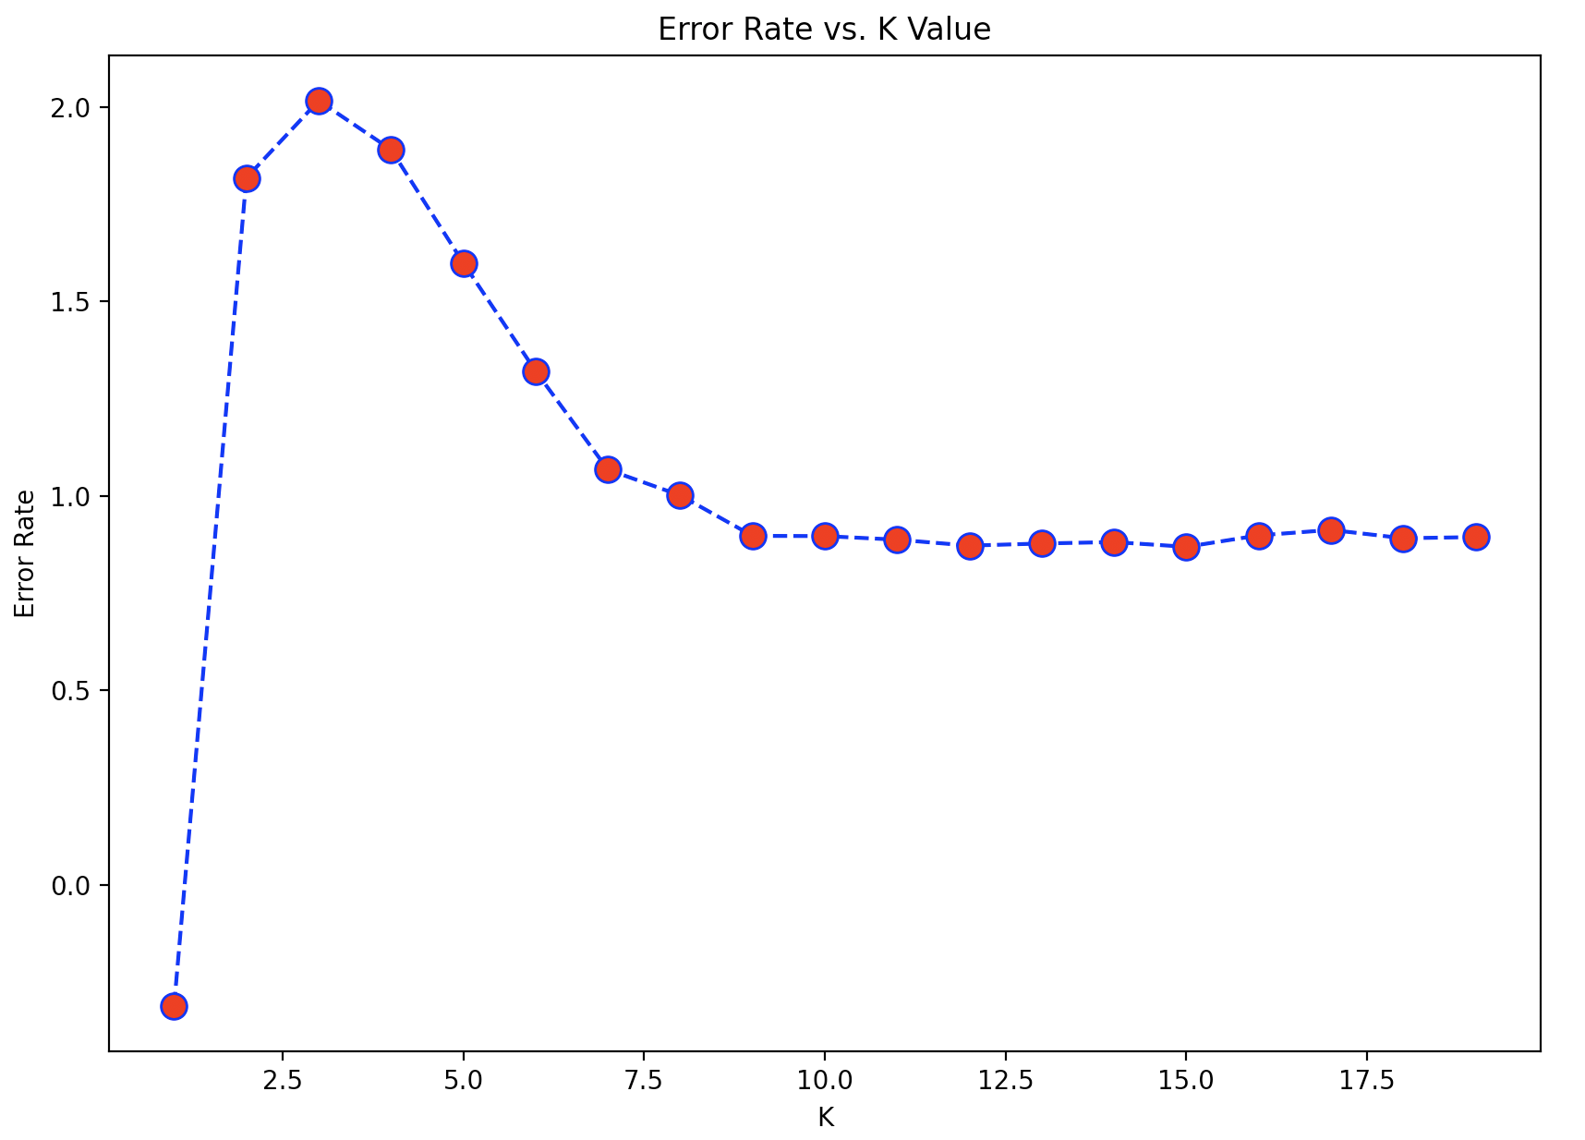

Based on this plot, generated in the script (“model_building_knn.py”), we can see that the optimal K value for this analysis is around 10, because it gets a lower error rate.

**Evaluation**

Both methods predicted the number of bikes available pretty well, in both cases the model was trained with 80% of the information and tested with the remaining 20%.

In this first plot we can see the result of the Liner Regression Method comparing the bikes available and the value predicted for the model in the first 40 values predicted.

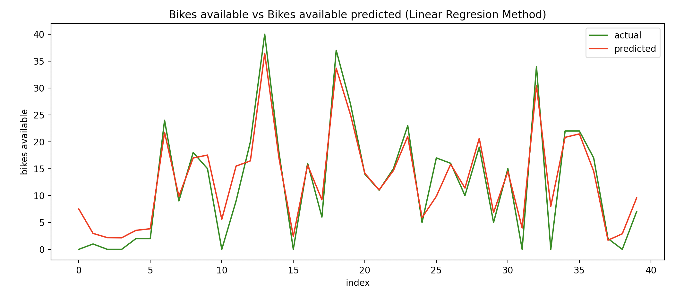

In this second plot using the algorithm K-nearest neighbors we can see the same comparison between bikes available and the model prediction of bikes available in the first 40 values predicted by the model.

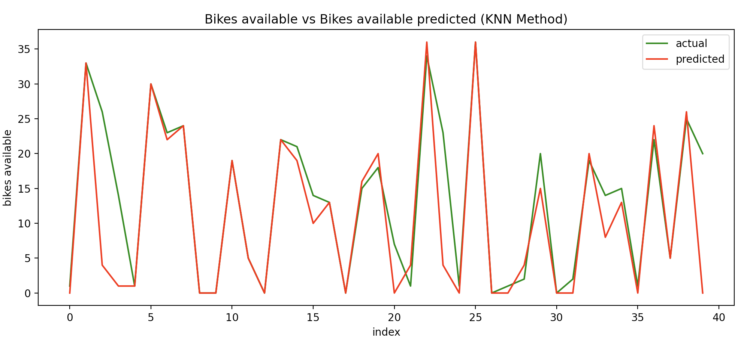

In the following table we can see the error comparison between both methods Mean Absolute Error (MAE) and Root Mean Squared Error (RMSE)

|  |  |  |
| --- | --- | --- |
| **Error Type** | **Linear Regression** | **Knn** |
| MAE | 3.169477 | 3.312921 |
| RMSE | 5.124050 | 5.890821 |

Both results show a similar error rate, but Linear Regression performed a little bit better than K-nearest neighbors.

As conclusion I would say that even when the models predicted the bikes available with a relative good accuracy, I realize that both models depend mainly on the numbers of bikes available at that moment, this is why that attribute has a Pearson’s correlation of 0.865, while the rest of attributes have a Pearson’s correlation of less than 0.15, while it could mean that bicycles are equally used despite the weather conditions or the time maybe because the bike station is near to a hospital, I also would say that there is an information not present in the dataset that could have changed this correlation, which is the number of bicycles put into the station by the service provider. Usually there are trucks moving the bikes to the busiest stations, in order to keep them with bicycles available.

With the information obtained it is also possible to predict the number of bicycles in two or more hours, while the error rate is going to increase, anyway it would be useful information that can be included in the service provider app to help customers to plan their route and improve their customer experience.